Carleton University

Assignment 1

SYSC5104 Meth Discrete Event Modeling
Fall 2021
Dr. Cristina Ruiz Martin

Mahya Shahmohammadimehrjardi
Student ID: 101213253

In this assignment, I converted the garage door model wrote in CD++ by Bengu Balya in Fall 2003 at Carleton University to Cadmium. This model consists of six atomic models; code controller, door timer, counter, alarm generator, indoor lightening and outdoor lightening.
Code controller, door timer and counter atomic models form a coupled model called door controller. Figure.1 shows this coupled model and its components.
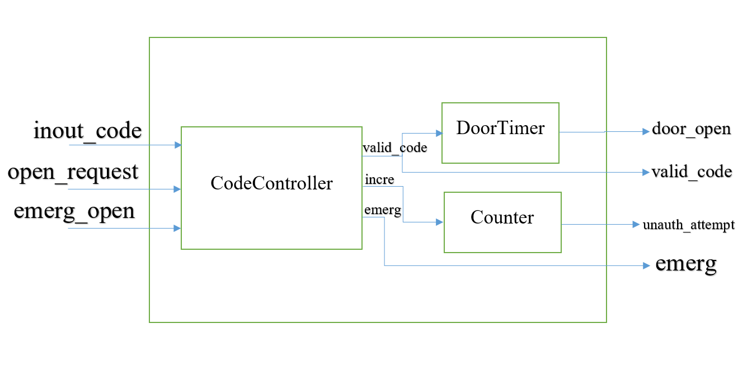
Fig. 1. DoorController Coupled Model
As shown in figure.1, code controller has three inputs; input_code, open_request and emerg_open and three outputs as valid_code, incre and emerg.
The pass code to the garage door is being set by the input_code. Open_request is for the user to enter the pass code. If the pass code is correct, the code controller generates an output called valid_code to the door timer atomic model and tells it to open the door. If the pass code entered is incorrect, the code controller atomic model generates and output called incre which counts as an input for the counter atomic model and counts the unauthorized attempts. Another input of the code controller atomic model is emerg_open which is a push button and generates an output called emerg and tell the alarm generator atomic model to generates a major alarm.
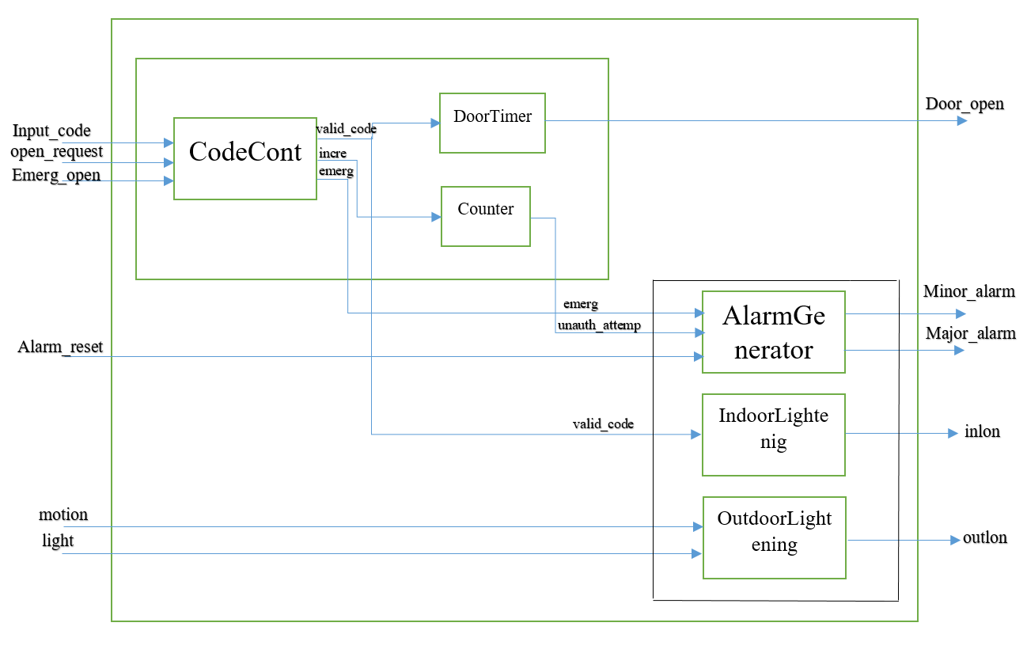
Fig.2. Top Model

Figure.2 shows the top model; the door controller, coupled with three other atomic models; Alarm generator, Indoor lightening and Outdoor lightening.
These three atomic models are defined as another coupled model called alarm_light_controller that has three external inputs; alarm_reset, motion and light. And four external outputs; minor_alarm, major_alarm, inlon and outlon. As it is shown in fig.2, there is no internal couplings for this coupled model because the atomic models work independently and none of the output of one atomic models goes into another atomic model as an input.
Alarm generator, generates a minor alarm when unauthorized attempts reach an amount defined in the counter atomic model. Alarm generator, generates a major alarm when state of the emerg input is true, which means if the emerg_open push button is pressed. The Alarm generator can be reset via Alarm_reset after a minor alarm or major alarm are generated.
Indoor lightening controls the indoor lights; the lights inside the garage are turned on when someone enters a valid pass code.
The Outdoor lightening atomic model, controls the outdoor lights; the outside lights are turned on when either there is motion detected by the motion sensors or light detected by the light sensors.
Every individual atomic models and the coupled models (door controller and alarmlight controller) are described below.

Code Controller:
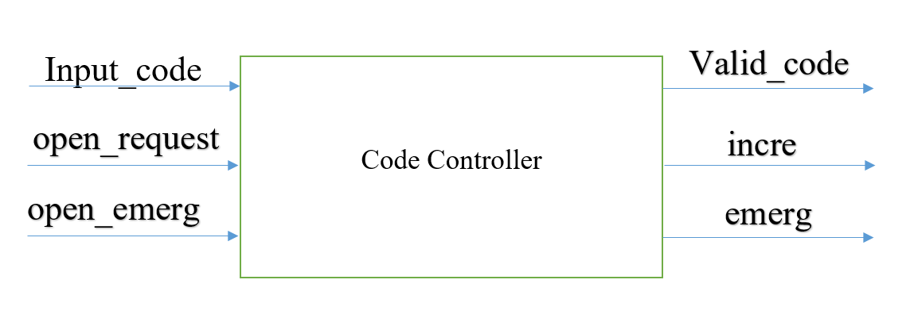

CodeCont = < S, X, Y, δint, δext, λ, ta >
X = {input_code, open_request, emerg_open}
Y = {valid_code, emerg, incre}
S: {ifemerg, ifvalid, ifnotvalid, enterinputcode, inputcodeset}

δint = δint (ifnotvalid)= inputcodeset

δext = δext(enterinputcode, input_code)= inputcodeset
δext = δext(inputcodeset, open_request)= ifvalid
δext = δext(inputcodeset, open_request)= ifnotvalid

δext = δext(inputcodeset, emerg_open)= ifemerg
δext = δext(enterinputcode, emerg_open)= ifemerg
Output Function:
λ(ifemerg)= emerg
λ(ifvalid)= valid_code
λ(ifnotvalid)= incre

Door Timer:
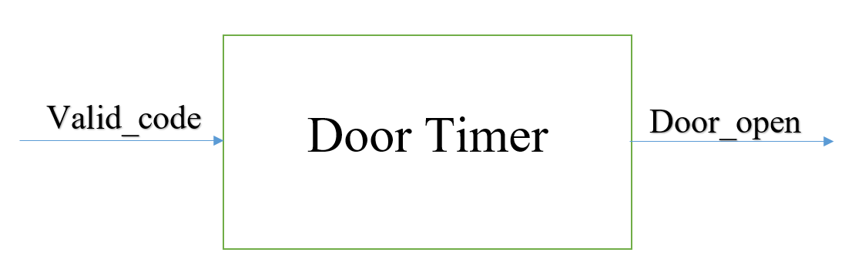
DoorTimer = < S, X, Y, δint, δext, λ, ta >
X = {valid_code}
Y = {door_open}
S: {ifopen, close}

δint = δint (ifopen)= close

δext = δext(close, valid_code)= ifopen
δext(close, valid_code)= close
δext(ifopen, valid_code)= ifopen
δext(ifopen, valid_code)= close

Output Function:
λ(ifopen) = door_open

Counter:
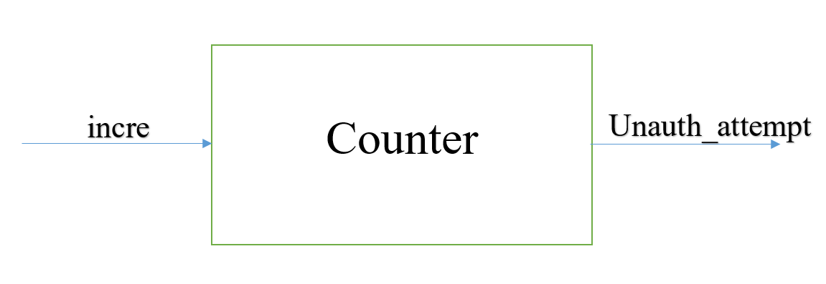
Counter = < S, X, Y, δint, δext, λ, ta >
X = {incre}
Y = {unauth_attempt}
S: {ifreachlimit, ifnotreachlimit}

δint = δint(ifreachlimit)= ifnotreachlimit
δext = δext(ifnotreachlimit, incre)= ifreachlimit
δext(ifnotreachlimit, incre)= ifnotreachlimit
Output Function:
λ(ifreachlimit) = unauth_attempt

Alarm Generator:
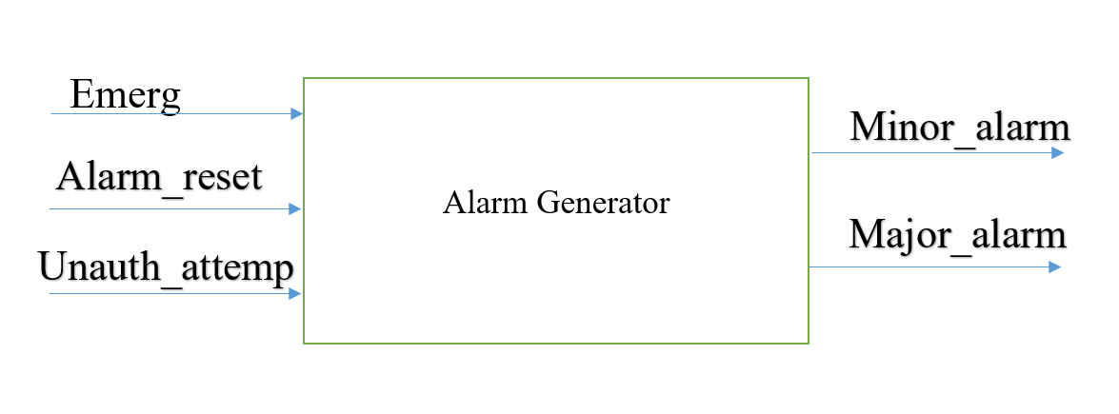
AlarmGenerator = < S, X, Y, δint, δext, λ, ta >
X = {emerg, alarm_reset, unauth_attempt}
Y = {minor_alarm, major_alarm}
S: {ifemerg, ifunauth_attempt, reset}

δint = does not exist

δext = δext(reset, emerg)= ifemerg
δext(reset, unauth_attempt)= ifunauth_attempt
δext(reset, unauth_attempt)= reset
δext(ifunauth_attemp, emerg)= ifemerg
δext(ifunauth_attempt, alarm_reset )= ifunauth_attempt
δext(ifunauth_attempt, alarm_reset )= reset

δext(ifemerg, alarm_reset )= reset

Output Function:
λ(ifunauth_attempt) = minor_alarm
λ(ifemerg) = major_alarm

Indoor Lightening:
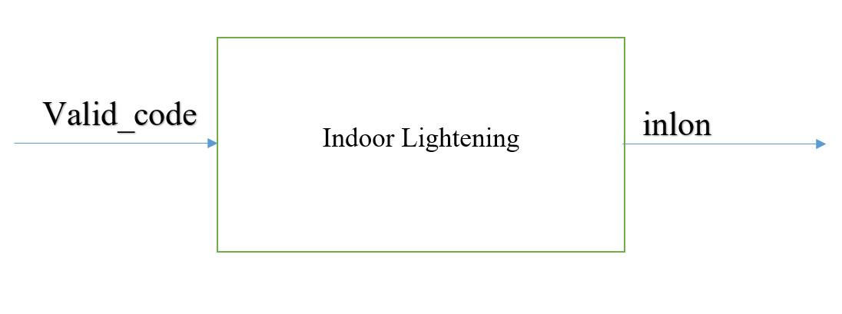
IndoorLightening = < S, X, Y, δint, δext, λ, ta >
X = {valid_code}
Y = {inlon}
S: {ifon, ifoff}

δint = δint(ifon)= ifoff

δext = δext (ifon, valid_code) = ifon
δext (ifoff, valid_code) = ifon

Output Function:
λ(ifon) = inlon

Outdoor Lightening:
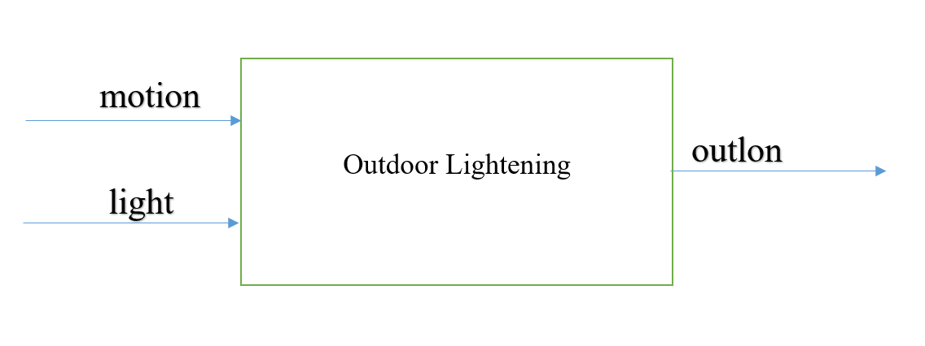
OutdoorLightening = < S, X, Y, δint, δext, λ, ta >
X = {motion, ligh}
Y = {outlon}
S: {ifon, ifoff, ifnight}

δint = δint(ifon)= ifoff

δext =
δext (ifoff, light) = ifoff
δext (ifoff, light) = ifnight
δext (ifnight, motion) = ifon
δext (ifnight, motion) = ifoff

Output Function:
λ(ifon) = outlon
github repository address of this project is provided below:

